Scene Builder
https://gluonhq.com/products/scene-builder/#download
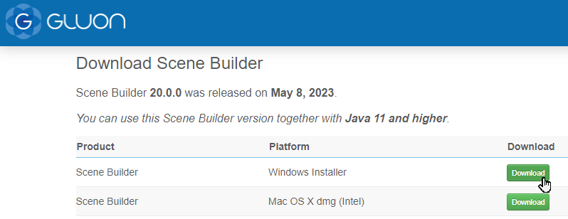
Indítás, Next, Install
intelliJ IDEA-ban:
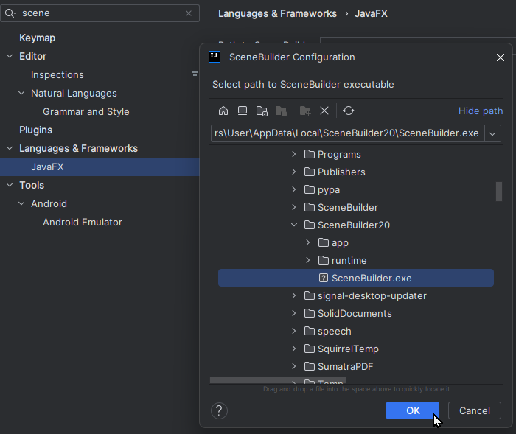

Új JavaFX projekt
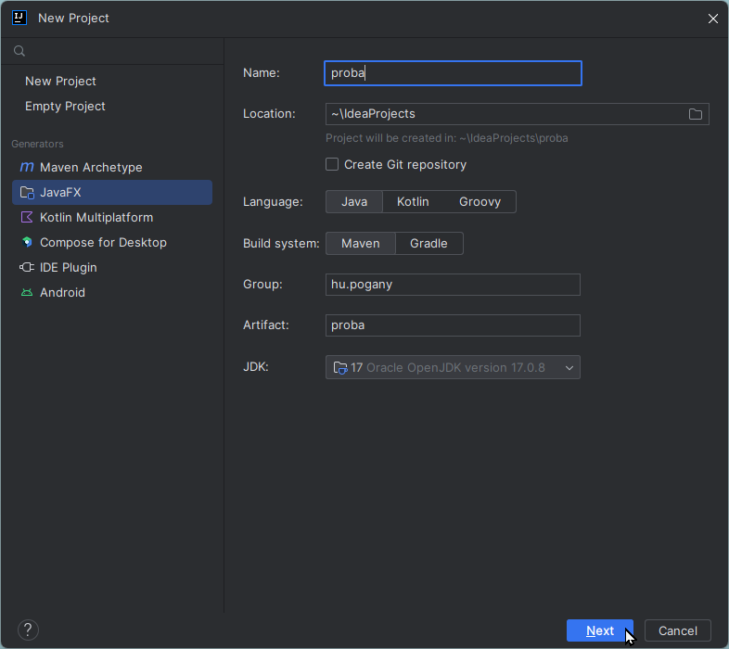
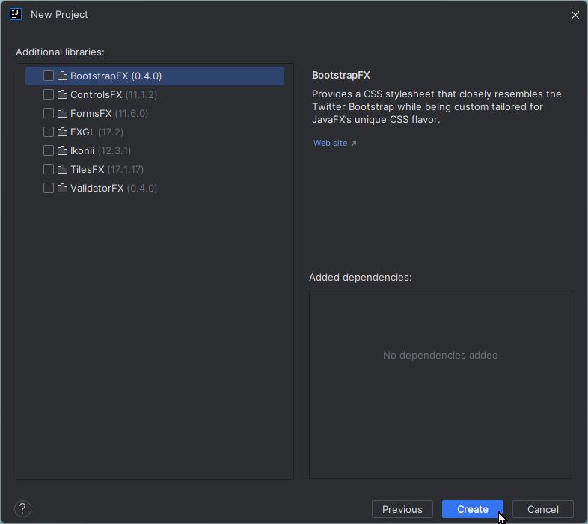

Plug-in


